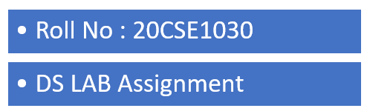

In this program, a function is declared which shift each element one index to the left.  
Before shifting the elements, we save the first element in a variable, which later is assigned to the last index to complete the cycle.

PROGRAM 1: WRITE A PROGRAM TO CYCLICALLY ROTATE AN ARRAY BY ONE.

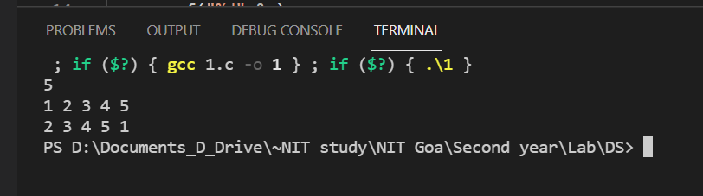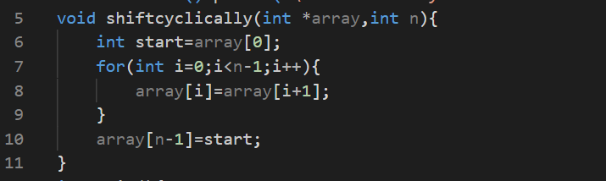

I/O of the program is as follows:

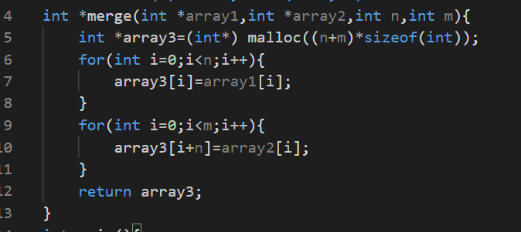  
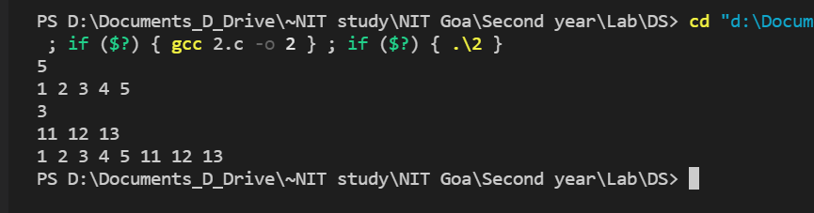

In this program, a function is declared which initializes a dynamic array of size, sum of sizes of two input array. Thereafter the for loop copies all the elements of first array into the new array followed by copying of all the elements of the second array into the new array.

PROGRAM 2: WRITE A PROGRAM TO MERGE TWO ARRAYS USING THIRD ARRAY.

I/O of this program is as follows:

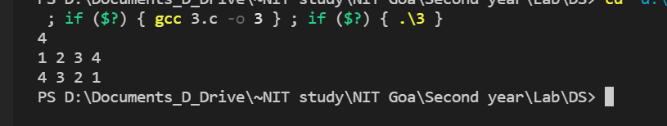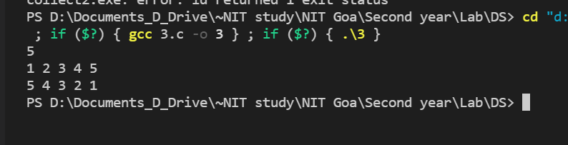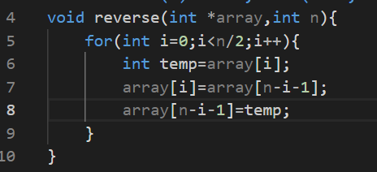

I/O of this program is as follows:

In this program, a function is declared which runs a for loop till the half of the array. In each iter, we swap the corresponding elements which are equidistant from the center of the array on each side.

PROGRAM 3 WRITE A PROGRAM TO REVERSING ELEMENTS OF AN ARRAY.